A Study of Genesis 12-25
创12-25研经
LESSON 10
第十课
ABRAHAM AND SARAH HAVE A SON – GENESIS 21
亚伯拉罕和撒拉得了儿子

INTRODUCTION
When Abraham was 75 years old (and Sarah was 65) the Lord promised him, “I will make you into a great nation” (Genesis 12:2). As the years passed and Sarah remained unable to have children, it seemed that God’s promise would be kept in some other way than through a child born to this couple.
But nothing is impossible for God. When Abraham was 100 years old and Sarah was 90, God kept his promises and brought about a miraculous event, the birth of a son to Abraham and Sarah. The narrative in this chapter records the fulfillment of the Lord’s words in Genesis 18:10 - “I will surely return to you about this time next year, and Sarah your wife will have a son.”
当亚伯拉罕75岁时（撒拉65岁），上帝向他承诺："我必叫你成为大国"（创世纪12：2）。随着岁月的流逝，撒拉仍然无法生育，似乎上帝的承诺将通过其他方式来实现，而不是通过这对夫妇所生的孩子。
但对上帝来说没有什么是不可能的。当亚伯拉罕100岁，撒拉90岁时，神遵守了他的承诺，施行了神迹，亚伯拉罕和撒拉得了自己的儿子。本章的叙述记录了耶和华在创世记18:10中的话如何得以应验-"到明年这时候，我必要回到你这里；你的妻子撒拉必生一个儿子。"

READ GENESIS 21:1-7 阅读《创世纪》21:1-7
The birth of Isaac was a gift of God’s grace and a fulfillment of God’s promises. The apostle Paul wrote: “Abraham had two sons, one by the slave woman and the other by the free woman. His son by the slave woman was born in the ordinary way; but his son by the free woman was born as the result of a promise” (Galatians 4:22–23).
以撒的出生是神的恩典，是神应许的应验。使徒保罗写道："亚伯拉罕有两个儿子，一个是使女生的，一个是自主之妇人生的。然而，那使女所生的是按着血气生的；那自主之妇人所生的是凭着应许生的。"（加拉太书4：22-23）。

- What two phrases in these verses proclaim God’s faithfulness to his promises?
这些经文中的哪两个短语宣告了神信实的持守了祂的应许？

Verse 1 第一节=

Verse 2 第二节=

- Why did Abraham and Sarah name their son Isaac? (see Genesis 17:19)
亚伯拉罕和撒拉为什么给他们的儿子取名为以撒？(见创世纪17:19)

- In verse 4 we read that Abraham had Isaac circumcised when the baby was 8 days old. Why was this important?
第4节告诉我们亚伯拉罕在以撒出生第8天时给他行了割礼。为什么这很重要？

READ GENESIS 21:8-21阅读《创世纪》21:8-21
A child is usually weaned from the mother’s breast at the age of 2 or 3. We know from Genesis 16:16 that Abraham was 86 years old when Ishmael was born. Now, Abraham was about 102 or 103 years old, which would mean that Ishmael was about age 15 or 16 when this incident took place.
孩子通常在2或3岁时断奶。我们从创世记16:16知道，以实玛利出生时亚伯拉罕已经86岁了。现在，亚伯拉罕大约是102或103岁，这就意味着，当这件事发生时，以实玛利大约是15或16岁。
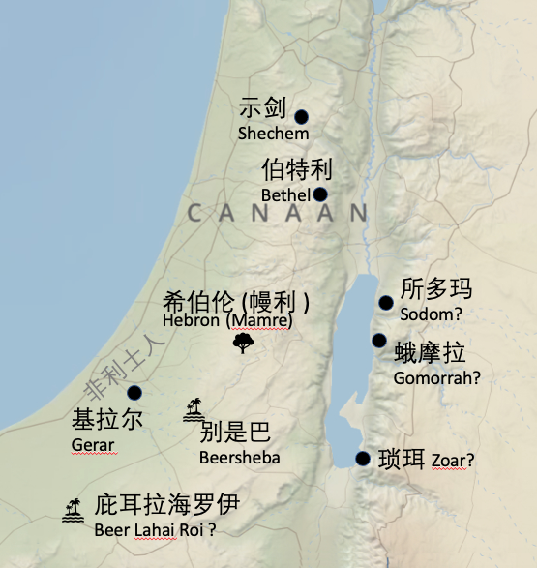
The weaning celebration was an opportunity to show special honor toward this baby boy. But in verse 9 we read that Ishmael was mocking Isaac at the very event meant to honor him. The apostle Paul gives us insight into Ishmael’s behavior toward Isaac. Paul wrote: “At that time the son born in the ordinary way persecuted the son born by the power of the Spirit” (Galatians 4:29). So it wasn’t just that Ishmael was having a little fun at Isaac’s expense, it was that Ishmael was engaged in persecution and abuse of the little boy. It sounds as if this wasn’t just a momentary or single occurrence, but it was especially grievous at the occasion when Ishmael should be honoring his little brother.
断奶的庆祝活动是为了给这个男婴尊荣。但在第9节中我们读到，以实玛利在这个旨在尊荣以撒的活动中戏笑他。使徒保罗让我们深入了解了以实玛利对以撒的行为。保罗写道："当时，那按着血气生的逼迫了那按着圣灵生的"（加拉太书4：29）。因此，这不仅仅是以实玛利在以撒身上找点乐子，而是以实玛利在迫害和虐待这个小男孩。听起来，这似乎不是一时或单一的事件，尤其是以实玛利本应该在这个庆祝活动中尊荣他的小兄弟，但他却戏笑以撒，这就特别令人难过。

- Why did Sarah feel threatened by Ishmael’s behavior toward Isaac?
以实玛利对以撒的行为为什么会使撒拉感觉受到了威胁？

- Previously, Abraham had told Sarah that she was free to send Hagar away (Genesis 16:6), but now he was distressed when Sarah demanded that he send away Hagar and Ishmael (v. 11). Why?
此前，亚伯拉罕曾告诉撒拉，她可以随意待夏甲。（创世记16:6），但现在当撒拉要求他送走夏甲和以实玛利时，他却感到忧愁（第11节）。为什么？

- In verse 13 God told Abraham, “I will make the son of the maidservant into a nation also, because he is your offspring.” Earlier, in Genesis 17:20 God had told Abraham, “As for Ishmael, I have heard you: I will surely bless him; I will make him fruitful and will greatly increase his numbers. He will be the father of twelve rulers, and I will make him into a great nation.” What great nation descended from Ishmael? See Genesis 25:12–18.在第13节中，神告诉亚伯拉罕："至于使女的儿子，我也必使他的后裔成立一国，因为他是你所生的。" 早些时候，在创世纪17:20，神告诉亚伯拉罕："至于以实玛利，我也应允你：我必赐福给他，使他昌盛，极其繁多。他必生十二个族长；我也要使他成为大国"。以实玛利是哪个大国的后裔？见创世纪25:12-18。

READ GENESIS 21:22-34阅读《创世纪》21:22-34
This incident shows us how powerful and respected Abraham was among the people of Canaan. It is also a record of the beginning of Abraham taking possession of the land of Canaan.
这件事让我们看到亚伯拉罕在迦南人中是多么强大和受人尊敬。这也是亚伯拉罕开始占有迦南地的记录。

- Who was Abimelech (verse 22)? See Genesis 20:2.
谁是亚比米勒（第22节）？见创世纪20:2。

- Why did Abimelech, the king of the Philistines, want to make a treaty with Abraham?
非利士人的王亚比米勒为什么要与亚伯拉罕立约？

- Why was the well at Beersheba important to Abraham?
为什么别是巴的井对亚伯拉罕很重要？

- What is the significance to the gift of “seven ewe lambs from the flock”?
"羊群中的七只母羊羔 "有什么特别的含义？

We read that Abraham planted a tamarisk tree at Beersheba. This is an indication that he intended to live there for a while. It takes a while for a tree to grow. With a tree and a well, Abraham would have a place to live.
我们读到，亚伯拉罕在别是巴种了一棵垂丝柳树。这表明他打算在那里居住一段时间。一棵树的成长需要一段时间。有了树和井，亚伯拉罕就有地方住了。

- In verse 33 we are told that Abraham “called upon the name of the LORD, the Eternal God.” What does that mean?
第33节告诉我们，亚伯拉罕 "求告耶和华—永生 神的名"。这是什么意思？

- Now, in our study of Abraham, God has been given three descriptive names. What are they?
到现在为止，在我们对亚伯拉罕的学习中，已经知道了三个描述神的名字。祂们分别是什么？
Genesis 14:18-19, 22 创世记14:18-19, 22 =

Genesis 17:1 创世记17:1 =

Genesis 21:33 创世记21:33 =

God has been revealing himself to Abraham and to us through these chapters. He wants us to know what the true God is like. He is the creator, almighty, and eternal.
神通过这几章向亚伯拉罕和我们彰显了自己。祂想让我们知道真正的上帝是什么样的。祂是创造者，是全能的，是永生的。

