GBI Course #106
恩典圣经学院课程 #106
A Study of Genesis 12-25
创12-25研经

LESSON 13
第十三课
ABRAHAM SECURES A WIFE FOR ISAAC – GENESIS 24
亚伯拉罕为以撒娶妻-创24

INTRODUCTION
简介
This chapter begins with the observation that the Lord had blessed Abraham in every way, according to the promise. God is faithful to his promises. This is one of the main themes of this entire study. No matter how impossible it may seem, and no matter how long it may take, God will keep his promises.
本章开始就指出一个事实，即：按照应许，耶和华在一切的事情上都赐福给亚伯拉罕。神信守承诺，这是该研经系列的主题之一。不管看起来多么不可能，也不论过了多长时间，神总会成就他的应许。
In this chapter Abraham carries out one of the duties of a father, namely, to find a suitable wife for his son to marry. In those times marriages were arranged by the parents and the children were expected to accept the arrangement and learn to live with the spouse that was given to them. Three years have passed since the death of Sarah at Hebron. Abraham was now 140 years old and Isaac was 40. It was time to find a wife for Isaac. This beautiful chapter describes the marriage of Isaac and Rebekah, truly a match made in heaven.
本章当中，亚伯拉罕履行了作为父亲的一项责任，就是为他的儿子娶一个合适的妻子。那时候，婚姻都是父母之命，孩子需要接受父母的安排，并且学着和配偶一起生活。这时，离撒拉死在希伯仑已经三年多了。亚伯拉罕已经一百四十岁，以撒也已经四十岁了。是时候给以撒娶妻了。这美妙的一章正是描述了以撒和利百加的婚姻，他们的确是天作之合。

READ GENESIS 24:1-9
阅读创24:1-9
The chief servant in Abraham’s household was probably Eliezer of Damascus at one time (Genesis 15:2). Perhaps Eliezer was still the chief servant and the one that Abraham entrusted with this important task.
管理亚伯拉罕全业的大管家仆有一段时间很有可能就是大马色人以利以谢（创15:2）。或许那时的大管家依旧是以利以谢，亚伯拉罕就把这个重要的任务托付给了他。
The method of taking a solemn oath by putting one’s hand “under the thigh” sounds like an odd thing to us. Why would someone place their hand near the private part of someone’s body? Perhaps this ritual of placing the hand near the father’s sexual organs was a way of expressing the importance of taking these steps to provide for the continuation of the ancestral line from which the promised Savior would one day come. We recall that Jacob made Joseph take an oath in a similar way (Genesis 47:29).
对我们来说，把手放在“大腿底下”起严肃的誓似乎很奇怪。为什么要让人把手放在接近身体隐私部位的地方呢？可能这个把手放在接近父亲性器官身体部位的仪式，是为了表达这么做为什么重要，是为了延续救主从其而出的家族传承。雅各曾经也让约瑟以相似的方式起誓（创47:29）。

- In regard to finding a wife for Isaac, what were two things that Abraham felt strongly about?
给以撒娶妻，亚伯拉罕最看重的两点是什么？

- Why was Abraham so concerned that Isaac must not marry a Canaanite woman (verse 3)?
亚伯拉罕为什么让以撒不要娶迦南妇人为妻（第3节）？

- Why did Abraham insist that Isaac not return to Mesopotamia in order to marry someone?
为什么亚伯拉罕坚持即使为了娶妻以撒也不能再回美索不达米亚？

- What made Abraham confident that the mission on which he was sending his servant would be successful?
是什么让亚伯拉罕有信心他差遣仆人的任务肯定能够完满完成？

- What makes you and me confident that God will be faithful to his promises and that we can trust him to do whatever he says? (see 2 Corinthians 1:20)
什么使得你我确信神会成就他的应许、我们可以相信神一定会成就他所说的话？（见林后1:20）

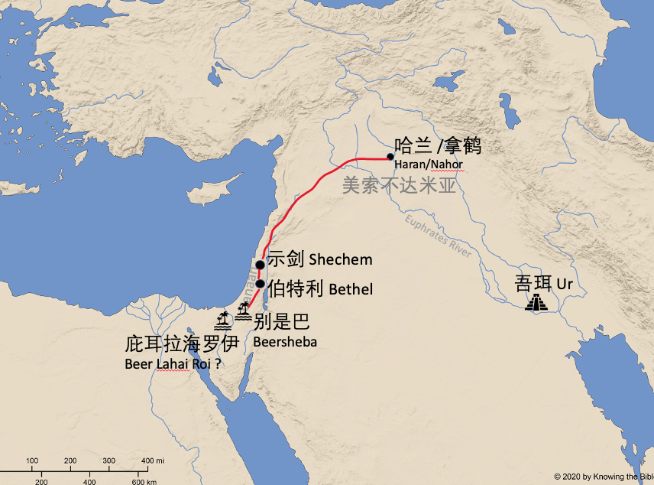
READ GENESIS 24:10-28
阅读创24:10-28
- Why did the servant take ten camels with “all kinds of good things from his master”?
为什么仆人要带着十匹骆驼，并带些“他主人各样的财物”？

- Why did the servant head for the city of Nahor?
仆人为什么要去拿鹤的城？

- What do the servants words in verse 12 and 26-27 reveal about him?
第12节以及第26-27节当中仆人所说的话，表明他是一个什么样的人？

- In verses 16-21 we read a description of Rebekah. What qualities in Rebekah made her an excellent choice to become the wife of Isaac?
第16-21节是对利百加的描述。利百加有哪些特质让她能够成为以撒的最佳伴侣？
- v.15 “she was the daughter of Bethuel son of Milcah”
第15节 “她是蜜迦之子彼土利的女儿”

- v.16 “very beautiful”
第16节 “容貌极其俊美”

- v.16 “a virgin”
第16节 “还是处女”

- v.18 “she gave him a drink”
第18节 “给他水喝”

- v.19-20 “I’ll draw water for your camels … until they have finished drinking … she went down to the spring, filled her jar and came up again … she drew enough for all his camels”
第19-20节 “我再为你的骆驼打水，叫骆驼也喝足。她又跑到井旁打水，就为所有的骆驼打上水来”

- v.65 “she took her veil and covered herself”
第65节 “利百加就拿帕子蒙上脸”

READ GENESIS 24:29-61
阅读创24:29-61

- What do the words of Laban and Bethuel in verses 50-51 reveal about them?
第50-51节当中拉班和彼土利的话表明他们是怎样的人？

- Rebekah met Abraham’s servant (Eliezer) on one day, and the next day she heard his proposal to return with him and marry Isaac (whom she had never met). Eliezer wanted her to leave home with him that same day. Her family thought it was too soon. However, she was asked (verse 55-57) if she would go, and she was willing. Why was this an act of faith similar to when Abraham left Haran?
利百加第一天遇到了亚伯拉罕的仆人（以利以谢），第二天就听到他请求她和他一起回去嫁给以撒（她连见都没有见过他）。以利以谢想让他当天就和他一起离开。她家人都认为太快了。但是，当问她（第55-57节）是否同去，她表示愿意。她出于信心的这一行为为什么和当初亚伯拉罕离开哈兰相似？

READ GENESIS 24:62-67
阅读创24:62-67

- In what ways did God bless the marriage of Isaac and Rebekah?
神在哪些方面祝福了以撒和利百加的婚姻？

The Bible often encourages us to choose a spouse who shares our Christian faith. When the people of Israel were about to enter the land of Canaan, Moses told his people: “When the Lord your God brings you into the land you are entering to possess and drives out before you many nations the Hittites, Girgashites, Amorites, Canaanites, Perizzites, Hivites, and Jebusites, seven nations larger and stronger than you and when the Lord your God has delivered them over to you and you have defeated them, then you must destroy them totally. Make no treaty with them. Do not give your daughters to their sons, for they will turn your sons away from following Me to serve other gods, and the Lord’s anger will turn against you and will quickly destroy you” (Deuteronomy 7:1-4).
圣经常常鼓励我们选择同有基督信仰的人作为配偶。当以色列人要进入迦南地的时候，摩西告诉百姓：“耶和华你神领你进入要得为业之地，从你面前赶出许多国民，就是赫人，革迦撒人，亚摩利人，迦南人，比利洗人，希未人，耶布斯人，共七国的民，都比你强大。耶和华你神将他们交给你击杀，那时你要把他们灭绝净尽，不可与他们立约，也不可怜恤他们。不可与他们结亲。不可将你的女儿嫁他们的儿子，也不可叫你的儿子娶他们的女儿。因为他必使你儿子转离不跟从主，去事奉别神，以致耶和华的怒气向你们发作，就速速地将你们灭绝。”
The faith of a prospective spouse must be an important consideration when decided who to marry.
在决定和谁结婚的时候，潜在配偶的信仰状况是一个非常重要的考量。

