GBI Course #106
恩典圣经学院课程 #106
ABRAHAM: THE FATHER OF BELIEVERS
亚伯拉罕：信徒之父
A Study of Genesis 12-25
创12-25研经

LESSON 5
第五课
HAGAR AND ISHMAEL – GENESIS 16
夏甲和以实玛利——创16

INTRODUCTION
简介
Precious as the promise of God to Abram had been, it had still left one point undetermined—who the mother of the promised seed was to be. Instead of waiting for the direction of God, Sarai was impatient and took action that was not only contrary to the will of God, but also caused her sorrow and disappointment.
尽管神给亚伯兰的应许非常宝贵，但是还有一点没有确定——谁是这个应许之子的母亲。撒莱没有等神的指示，她无法再等，就擅自行动了。她那么做不仅和神的旨意相悖，还给自己带来了痛苦和失望。
Ten years had elapsed since Abram had entered Canaan, when Sarai, despairing of giving birth to the heir of the promise, followed the common custom of those days and countries, and sought a son by an alliance between her husband and Hagar, her own Egyptian maid. The consequences of her folly were strife in her home, then reproaches, and the eventual flight of Hagar. What else might have followed it is difficult to tell, had not the Lord stepped in to rescue Hagar and Ishmael.
亚伯兰进入迦南已经十年了，撒莱对生出应许之子感到绝望，于是她随从当时的风俗，让他丈夫和自己的埃及使女夏甲结合生子。她的愚昧带来的后果先是家庭不和，然后就是谴责，最后则是夏甲逃走。如果耶和华没有救夏甲和以实玛利，很难讲还会发生什么。

READ GENESIS 16:1–6
阅读创16:1-6
- Who was Hagar and why was she with Abram and Sarai?
夏甲是谁？她为什么会和亚伯兰、撒莱在一起？

- Why did Sarai suggest that Abram father a child through Hagar?
撒莱为什么要建议亚伯兰通过夏甲得子？

- What was wrong with Sarai’s plan? Agree or disagree with these:
撒莱的计划有什么问题？下列陈述同意与否：
- It implied that God was taking too long.
这表示神花的时间太久了。
- It implied that God would not be able to keep His promise to give Abram and Sarai a child of their own.
这表示神无法实现他的应许，给亚伯兰和撒莱一个自己的孩子。
- It implied that faith in God’s promise wasn’t enough, but that human effort (works) was needed to reach the goal.
这表示仅仅是对神的应许有信心是不够的，还需要人的努力（工作）才能达到目标。
- It interfered with God’s plan.
这打乱了神的计划。
- It violated the sanctity of marriage.
这违背了婚姻的神圣。

- What sad consequences resulted from this sinful plan of unbelief?
这个出于不信的计划造成了什么令人伤心的后果？

The Bible records two more incidents when Abraham and Sarah failed to act as examples of faith. They are not the kind of things that we would expect people of such great faith to do. They agreed to take part in a plan of immoral deception. And this deception happens not just once, but three times in the book of Genesis. Twice Abraham passes his wife Sarah off as his sister (Genesis 12:10-20 and 20:1-18).
亚伯拉罕和撒拉出于不信而做的事情，圣经还记载了两件。像他们这样大有信心的人，我们根本不会想到他们居然会做那样的事情。他们参与了不道德的欺骗计划。而这种欺骗不只发生了一次，在创世纪当中发生了三次。有两次，亚伯拉罕假装妻子撒拉是自己的妹子（创12:10-20和20:1-18）。
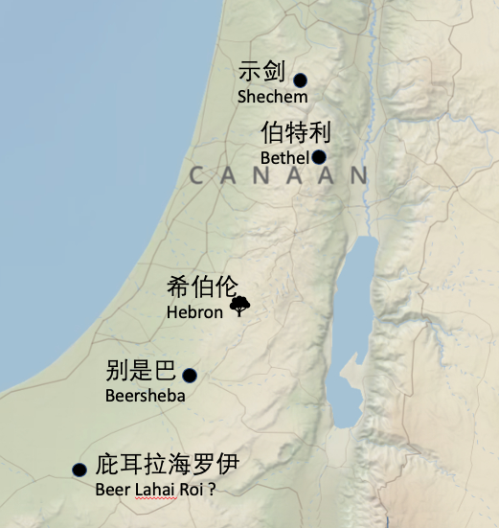
READ GENESIS 16:7–16
阅读创16:7-16
In order to escape mistreatment at the hand of Sarai, Hagar fled in the direction of Egypt. It would appear that she was heading back to her homeland. And now that Hagar had run away, it appears that instead of gaining a child, Abram and Sarai would lose a servant. This was the sad result of failing to follow God’s plan.
为了逃离撒莱的苦待，夏甲朝埃及方向逃跑。看起来，她应该是朝自己的家乡逃跑的。夏甲逃跑，亚伯兰和撒莱不但没有得到孩子，反而还失去了一个仆人。不遵行神的计划，就会造成不好的后果。
Then we read that the angel of the Lord appeared to Hagar in the desert. The Old Testament mentions the “angel of the Lord” quite often, and it appears that this was no ordinary angel. In verse 13 we have a hint as to the true identity of this angel.
然后我们就读到，耶和华的使者在旷野向夏甲显现。旧约经常提到“耶和华的使者”，他并非普通的天使。在第13节当中，我们能够得到关于该天使身份的暗示。
- Who was the “angel of the Lord” that appeared to Hagar according to verse 13?
根据第13节，谁是“耶和华的使者”？

- Why did the Lord appear to Hagar, speak to her, and stop her from running away?
为什么耶和华要向夏甲显现、同她说话，并且阻止她逃跑？

- What does the name “Ishmael” mean?
“以实玛利”是什么意思？

- What would Ishmael be like according to verse 12?
根据第12节，以实玛利将来会怎么样？

Hagar obeyed the Lord and returned to Abram’s tents. It seems that she resumed her role as a maidservant of Sarai (see chapter 21). Hagar must have told Abram and Sarai about the Lord’s appearance to her in the desert, because when she gave birth to a son, just as the Lord had said, Abram named him Ishmael, just as the Lord had told Hagar his name would be.
夏甲听了耶和华的话，回到了亚伯兰的帐棚那里。看起来她做回了撒莱的使女（见创第21章）。耶和华在旷野向她显现的事情，夏甲应该告诉了亚伯兰和撒莱，因为她生儿子的时候，就像耶和华所说的，亚伯兰给他起名叫以实玛利，正如耶和华告诉夏甲的那样。
Abram dearly loved Ishmael for he said to God: “If only Ishmael might live under your blessing!” (Genesis 17:18) But Ishmael was not to be the heir of the promise. The Lord had in mind to bring about a demonstration of his ability to keep his promise by sending another baby into the home of Abram and Sarai. And this time it would be the aged and barren Sarai who would bear that child.
亚伯兰很爱以实玛利，因为他对神说：“但愿以实玛利活在你面前”（创17:18）。但是以实玛利并非应许之子。耶和华赐给亚伯兰和撒莱另外一个孩子，彰显出他有能力成就他的应许。这一次，是年老无法生育的撒莱来生这个孩子。

- What lesson can we learn from Hagar’s attempt to run away from her problems?
夏甲试图逃离她的问题，从这一事件当中我们能够学到什么功课？

