GBI 106 课程
A Study of Genesis 12-25
查考创世纪 12-25

LESSON 7
第七课
ABRAHAM’S VISITORS – GENESIS 18
亚伯拉罕的访客—创世纪18章

INTRODUCTION
介绍
About 25 years had passed since the Lord promised Abram and Sarai: “I will make you into a great nation” (Genesis 12:2). Abraham correctly understood this to mean that he would have many descendants. But as the years passed, Sarah remained barren.
But now three visitors came to Abraham sitting at the entrance to his tent. They had an important announcement for Abraham and Sarah. They repeated the promise first given so many years before and assured Abraham and Sarah that within a year they would have a baby of their own. God would suspend the laws of nature and give a barren old woman and her 100-year old husband the gift of a miracle child.
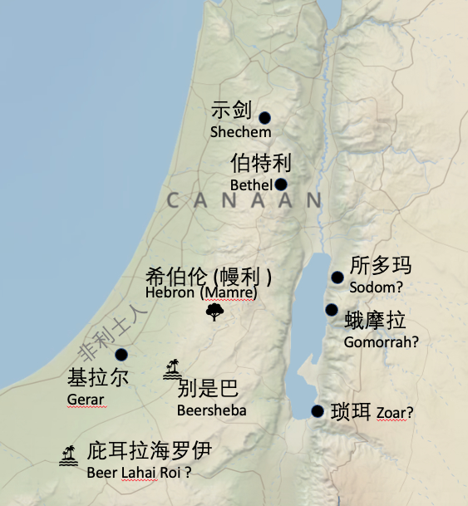
自从主应许亚伯兰和撒莱：我必叫你成为大国”（创世记 12:2）以来，已经过去了大约 25 年。 亚伯拉罕正确地理解这意味着他将有许多后裔。 但随着岁月的流逝，撒拉仍然不育。
但是现在三个访客来到亚伯拉罕坐在他帐棚的入口处。 他们向亚伯拉罕和撒拉宣布了一个重要的消息。 他们重复了多年前首次给予的应许，并向亚伯拉罕和撒拉保证，他们将在一年内怀上自己的孩子。 神会暂停自然法则，赐给一个不育的老妇人和她 100 岁的丈夫从神迹而来的孩子作礼物。

READ GENESIS 18:1-15
阅读创世纪18:1-15
- Who were the three strangers that visited Abraham’s camp?
到亚伯拉罕帐棚的3名陌生来访者是谁？

- What news did the three visitors share with Abraham (v.10)?
三个访客告诉亚伯拉罕什么消息(10节)

- Why did Sarah deny that she laughed when she overheard the Lord’s announcement?
为什么撒拉不承认她听到神宣告的消息时笑了？

- What is the answer to the Lord’s question in verse 14?
在第14节，主的问题的答案是什么？

- Jesus once told his disciples, “With humans this is impossible, but with God all things are possible.” (Matthew 19:26) What is impossible for humans to do, but not too hard for the Lord?
耶稣曾对门徒说：“在人这是不能的，在神凡事都能。”（马太福音19:26）有什么是人不能做的，但对主来说不是太难的事？

READ GENESIS 18:16-33 读创世纪18:16-33
- Abraham’s three visitors had come for two reasons. The first was to announce that Abraham and Sarah would have a son in one year (verse 10). What was the second reason (verses 20-21)?
亚伯拉罕的三位客人来了有两个原因。 第一个是宣布亚伯拉罕和撒拉将在一年内生一个儿子（第 10 节）。 第二个原因是什么（20-21 节）？

God wanted Abraham to know that a day of judgment was coming for the cities of Sodom and Gomorrah. “Shall I hide from Abraham what I am about to do?” the Lord said to Himself. God gives warnings about His judgments. Before the flood, God waited many years and had Noah build an ark so that the people would have every opportunity to repent and turn back to Him.
And the Lord has also clearly told us that a day of judgment is coming for the entire earth. Jesus said: “But I tell you that men will have to give account on the day of judgment for every careless word they have spoken. For by your words you will be acquitted, and by your words you will be condemned.” (Matthew 12:36–37). The Lord has not hidden what He is about to do but has revealed that a day of judgment is coming. Why? So that we will be prepared. So that we will repent. God’s warning is an act of mercy. His apostle writes “The Lord is patient with you, not wanting anyone to perish, but everyone to come to repentance.” (2 Peter 3:9).
神希望亚伯拉罕知道审判的日子将临到所多玛和蛾摩拉两座城市。 “我要对亚伯拉罕隐瞒我将要做的事吗？”主对自己说。神对他的审判发出警告。在洪水之前，神等了很多年，让诺亚建造方舟，让人们有机会悔改并转向他。
主也清楚地告诉我们，审判的日子将临到全地。耶稣说：”我又告诉你们，凡人所说的闲话，当审判的日子必要句句供出来。因为要凭你的话定你为义，也要凭你的话定你有罪。”（马太福音 12：36-37）。主并没有隐瞒他将要做的事，而是显明审判的日子即将来临。为什么？以便我们做好准备。好让我们悔改。神的警告是一种怜悯的行为。他的使徒写道：“主所应许的尚未成就，有人以为他是耽延，其实不是耽延，乃是宽容你们，不愿有一人沉沦，乃愿人人都悔改” （彼得后书 3：9）。
- Why was Abraham concerned about the Lord’s impending judgment upon Sodom and Gomorrah?
为什么亚伯拉罕担心主即将对所多玛和蛾摩拉的审判？

- What was it like for Lot and his family to live in Sodom and Gomorrah? Read 2 Peter 2:7-8 and summarize the description of Sodom and Gomorrah in those verses.
罗得和他的家人住在所多玛和蛾摩拉是什么感觉？ 阅读彼得后书 2：7-8 并总结这些经文中对所多玛和蛾摩拉的描述。

- In verses 20-21 the LORD said, “The outcry against Sodom and Gomorrah is so great and their sin so grievous that I will go down and see if what they have done is as bad as the outcry that has reached me. If not, I will know.” Was the LORD uncertain about how bad things were in Sodom and Gomorrah? Did the Lord not know the true condition of those cities?
在 20-21 节，耶和华说：“耶和华说：“所多玛和蛾摩拉的罪恶甚重，声闻于我。我现在要下去，察看他们所行的，果然尽像那达到我耳中的声音一样吗？若是不然，我也必知道。”耶和华是否不确定所多玛和蛾摩拉的情况有多糟糕？ 主不知道那些城市的真实情况吗？

- How would you answer Abraham’s questions in verses 23-25?
你会如何回答亚伯拉罕在 23-25 节中的问题？

As Abraham lowers the number of righteous people in Sodom, he appeals to God’s mercy. Surely there had to be other righteous and god-fearing people in Sodom besides Lot and his family! But Abraham wasn’t sure. So he bargained with the Lord not to destroy the city for the sake of 45 or 40 or 30 or 20 or even 10. But, unfortunately, there weren’t even ten righteous people left in Sodom.
Yet, listen to the Lord’s response. How deep did His mercy run? As the number grew smaller and smaller, God’s mercy grows larger and larger, and this truth is impressed upon us: The Lord will not destroy those who trust in Him on the day of judgment.
当亚伯拉罕减少所多玛义人的数量时，他祈求神的怜悯。除了罗得和他的家人之外，所多玛肯定还有其他正义和敬畏神的人！但亚伯拉罕并不确定。所以他与主讨价还价，不要为了45个、40个、30个、20个、甚至10个而毁灭这座城市。但不幸的是，所多玛连十个义人都没有留下。
然而，聆听主的回应。祂的怜悯有多深？随着人数越来越少，神的怜悯也越来越大，给我们留下了深刻的印象：在审判的日子，主不会毁灭信靠​​他的人。

In conclusion, listen to these words of St. Peter: “For if God … condemned the cities of Sodom and Gomorrah by burning them to ashes, and made them an example of what is going to happen to the ungodly; and if he rescued Lot, a righteous man, who was distressed by the filthy lives of lawless men (for that righteous man, living among them day after day, was tormented in his righteous soul by the lawless deeds he saw and heard)— if this is so, then the Lord knows how to rescue godly men from trials and to hold the unrighteous for the day of judgment” (2 Peter 2:4–10). Amen.
最后，请听听圣彼得的这些话：“就是天使犯了罪，神也没有宽容，曾把他们丢在地狱，交在黑暗坑中，等候审判。神也没有宽容上古的世代，曾叫洪水临到那不敬虔的世代，却保护了传义道的挪亚一家八口。又判定所多玛、蛾摩拉，将二城倾覆，焚烧成灰，作为后世不敬虔人的鉴戒；只搭救了那常为恶人淫行忧伤的义人罗得，因为那义人住在他们中间，看见听见他们不法的事，他的义心就天天伤痛。主知道搭救敬虔的人脱离试探，把不义的人留在刑罚之下，等候审判的日子。那些随肉身纵污秽的情欲、轻慢主治之人的，更是如此。他们胆大任性，毁谤在尊位的也不知惧怕。”（彼得后书 2：4-10）。阿门。

