GBI Course #106
恩典圣经学院课程 #106
ABRAHAM: THE FATHER OF BELIEVERS
亚伯拉罕：信徒之父
A Study of Genesis 12-25
创12-25研经

LESSON 9
第九课
ABRAHAM AND ABIMELECH – GENESIS 20
亚伯拉罕和亚米比勒-创20

INTRODUCTION
简介
In chapter 20 the focus of the account returns to Abraham and Sarah. When the events described in this chapter took place, Sarah may have already been pregnant, because the Lord had told them in Mamre, “I will surely return to you about this time next year, and Sarah your wife will have a son” (Genesis 18:10).
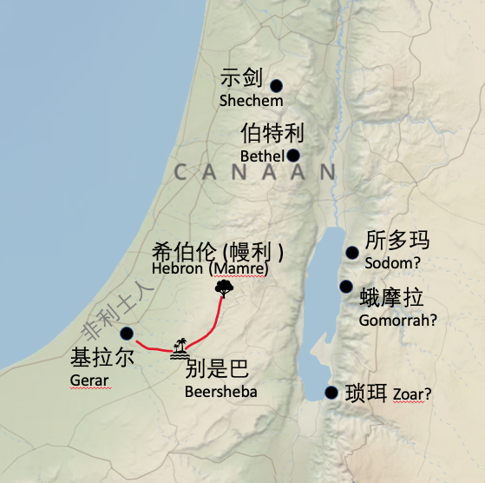
第二十章的焦点重新回到亚伯拉罕和撒拉。本章描述的事件发生的时候，撒拉可能已经怀孕，因为耶和华在幔利已经告诉他们：“到明年这时候，我必要回到你这里。你的妻子撒拉必生一个儿子”（创18:10）。
Abraham and his family had lived near Mamre for about 20 years. But now something led them to relocate. Perhaps there was a famine. Perhaps there was simply a need to move to new pastureland. Whatever the case may have been, Abraham eventually came to live near Gerar in the land of the Philistines.
亚伯拉罕一家住在幔利附近已经大概二十年。但是现在，他们需要重新安家。或许是由于发生了饥荒，也或许仅仅是为了搬到新的牧地。不论原因为何，最终，亚伯拉罕寄居在非利士地的基拉耳附近。

READ GENESIS 20:1–13
阅读创20:1-13
This is the second time that something like this happened. The first time Abraham lied about his wife was in Genesis 12:10-20, when Abram and Sarai agreed to lie to the Egyptians. Now the same sin is repeated again.
类似事件这是第二次。第一次是在创12:10-20，亚伯拉罕在妻子的事情上说谎，那时亚伯兰和撒莱商量好对埃及人撒谎。现在则是再一次犯同样的罪。

- What motivated Abraham and Sarah to lie about their relationship (20:11)?
什么促使亚伯拉罕和撒莱在二人的关系上说谎（20:11）？

In verse 3 God told Abimelech that he was as good as dead if would touch Sarah. Then he told Abimelech. “I have kept you from sinning against me. That is why I did not let you touch her. Now return the man’s wife, for he is a prophet, and he will pray for you and you will live. But if you do not return her, you may be sure that you and all yours will die.” (verses 6-7).
在第三节中，神告诉亚米比勒，如果他胆敢亲近撒拉，就是个死人。然后他告诉亚米比勒：“我也拦阻了你，免得你得罪我，所以我不容你沾着她。现在你把这人的妻子归还他。因为他是先知，他要为你祷告，使你存活。你若不归还他，你当知道，你和你所有的人都必要死”（第6-7节）。
- Why was God so intent on keeping Abimelech away from Sarah?
神为什么要让亚米比勒远离撒拉？

- What four excuses did Abram offer for his plan to deceive Abimelech? (20:11-13)
亚伯兰找了哪四个理由为欺骗亚米比勒开脱？（创20:1）

In 20:12 Abraham explains that Sarah was actually his half-sister, the daughter of his father, Terah, by another wife. Was marrying your half-sister allowed? Look at these verses:
亚伯拉罕在创20:12节当中解释说，撒拉是他的父亲他拉的女儿，是他同父异母的妹妹。和同父异母的姐妹结婚可以吗？请看下列经文：
- Ezekiel 22:11 - “In you one man violates his sister, his own father’s daughter.”
结22:11-“还有玷辱同父之姐妹的。”
- Leviticus 18:3, 9 - “You must not do as they do in Egypt, where you used to live, and you must not do as they do in the land of Canaan, where I am bringing you. Do not follow their practices. Do not have sexual relations with your sister, either your father’s daughter or your mother’s daughter, whether she was born in the same home or elsewhere.”
利18:3,9-“你们从前住的埃及地，那里人的行为，你们不可效法，我要领你们到的迦南地，那里人的行为也不可效法，也不可照他们的恶俗行。你的姐妹，不拘是异母同父的，是异父同母的，无论是生在家生在外的，都不可露她们的下体。”
Let’s remember that the commandments God gave to Moses were hundreds of years after the time of Abraham. As the human race began to re-populate the world after the flood, marrying those who were related to you was often necessary and not as awful as it came to be later. We do not know for sure whether Terah was married before or after he was married to Abraham’s mother.
我们知道，亚伯拉罕之后几百年，神才给摩西的律法。洪水之后，人类重新繁衍在世上居住，那时，近亲结婚是有必要的，不像后来那么不好。我们不知道他拉娶撒拉的母亲是在娶亚伯拉罕的母亲之前还是之后。

READ GENESIS 20:14–18
阅读创20:14-18
- It is clear that Abraham and Sarah were lying and deceiving Abimelech. So why did they prosper as a result of it?
显然，亚伯拉罕和撒拉在撒谎欺骗亚米比勒。那么，为什么他们却因此而发达呢？

Let’s analyze the lie/half-truth that Abraham and Sarah engaged in. Was it a lie or not? Is telling a half-truth a lie? Is telling only part of the truth the same as lying? And if they were lying, why weren’t they punished for it?
我们来分析一下亚伯拉罕和撒拉所说的谎言/半真实的话。那是不是谎言？只说一半的真话是撒谎吗？只说部分真话是撒谎吗？如果他们在撒谎，为什么他们没有受到惩罚呢？
The Scripture contains several incidents when people told lies and were not punished for it, but even commended for it.
圣经记载了几次事件，人们撒谎了，但是不仅没有因之受到惩罚，反而甚至得到赞许。
The Hebrew midwives Shiphrah and Puah lied about (Exodus 1:15-21) the birth of the baby boys and God blessed them for it. Rahab lied about the spies that she hid in her house (Joshua 2:4-7) and the New Testament even commends her for what she did. (“In the same way, was not even Rahab the prostitute considered righteous for what she did when she gave lodging to the spies and sent them off in a different direction?” -- James 2:25)
希伯来收生婆施弗拉和普阿在男婴出生一事上撒谎（出1:15-21），神因此厚待她们。喇合在把探子藏在房子里的事情上撒谎（书2:4-7），新约甚至因此表扬她所做的事情。（ 妓女喇合接待使者，又放他们从别的路上出去，不也是一样因行为称义吗？-雅2:25）
But the Bible clearly condemns lying as a sin. “Do not lie. Do not deceive one another” (Leviticus 19:11). “The Lord detests lying lips, but he delights in men who are truthful” (Proverbs 12:22). “Do not lie to each other, since you have taken off your old self with its practices” (Colossians 3:9). And Ananias and Sapphira were struck dead when they told a lie (Acts 5).
但是圣经明确谴责撒谎是罪。“不可欺骗，也不可彼此说谎”（利19:11）。“说谎言的嘴，为耶和华所憎恶。行事诚实的，为他所喜悦”（箴12:22）。“不要彼此说谎，因你们已经脱去旧人和旧人的行为”（西3:9）。而亚拿尼亚和撒非喇因为撒谎被击杀（徒5）。
- Does God approve of lying in some (exceptional) cases? Where do we draw the line? For example, if you were applying for a job and they asked you, “What religion are you?” If you answer “Christian” then you will not get the job. What should you do?”
在一些（例外）情况下，神允许人撒谎吗？那么该如何界定这条线呢？例如如果你申请一个工作，他们问你，“你信什么教？”如果你回答“基督教”，你就得不到这份工作。那么你会怎么做？

- How did this event serve to advance the fulfillment of God’s promises to Abraham?
这一事件如何促使神向亚伯拉罕的应许成就？

Once again the events of this chapter reinforce God’s grace and faithfulness. In spite of Abraham’s failure to act in faith, God blessed him and turned what could have been a disaster into a way to bring even more blessings to Abraham and Sarah. It was as Abraham’s servant later declared: “Praise be to the LORD, the God of my master Abraham, who has not abandoned his kindness and faithfulness to my master.” (Genesis 24:27)
·本章的事件再次强调了神的恩典和信实。尽管亚伯拉罕没能凭着信心行事，神还是祝福了他，并且把本来的灾难化为了对亚伯拉罕和撒拉更多的祝福。正如后来亚伯拉罕的仆人宣告的那样：“耶和华我主人亚伯拉罕的神是应当称颂的，因他不断地以慈爱诚实待我主人”（创24:27）。
In our next lesson we will see how God kept one of his most important and seemingly impossible promises to give Abraham and Sarah a son in their old age.
下一课，我们会看到神如何成就他最重要的、看起来似乎不可能成就的应许，就是在亚伯拉罕和撒拉年老的时候赐给他们一个儿子。

