附录 4
Appendix 4

SYMBOLS AND ART符号和美术
Symbols and pictures have always been used in the Christian church and in connection with our worship.Pictures could tell Bible stories to Christians who could not read or who did not own Bibles.Symbols could be artistic reminders of Bible truths.Below are shown some of the most common Christian symbols and what they most commonly represent.
符号和图片常被用于基督教会和我们的敬拜中。图片能向不能阅读或没有圣经的基督徒讲述圣经故事。符号可以以艺术的方式来提醒我们关于圣经的真理。下面列出一些最常用的基督教符号以及它们通常所代表的意义。
符号（图片） | 所代表的意义
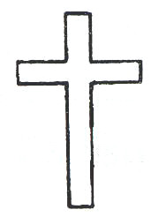 | Cross = Christ’s death for us十字架 = 基督为我们而死
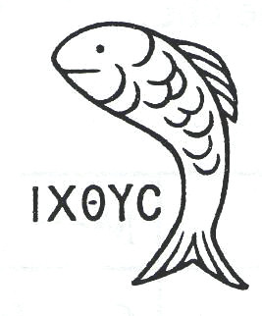 | Fish = Christ or Christian(Greek word for fish is made up of beginning letters of Jesus Christ, God ’s Son, Savior)  鱼 = 基督或基督徒 (希腊文“鱼”的每个字母是“耶稣基督，上帝的儿子，救主”的首字母缩写)
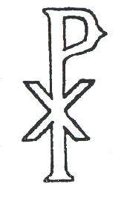 | Chi-Rho = Jesus Christ (The first 2 letters of the word Christ in Greek)  X P（Chi-Rho） = 基督（基督这个字的希腊文的头两个字母）
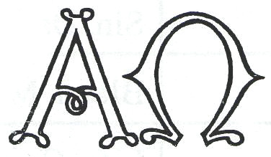 | Α and Ω = God as Eternal (Alpha and Omega, the first and last letters of the Greek alphabet; cf. Rev. 22:13)  Α 和 Ω =永恒的神（阿拉法与俄梅嘎是希腊字母表中的第一个字母和最后一个字母；参看启示录22:13）
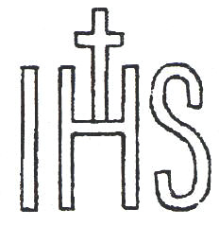 | IHS = Jesus (The first 3 letters of the name Jesus in Greek)  IHS = 耶稣(耶稣的希腊文写法的前三个字母)
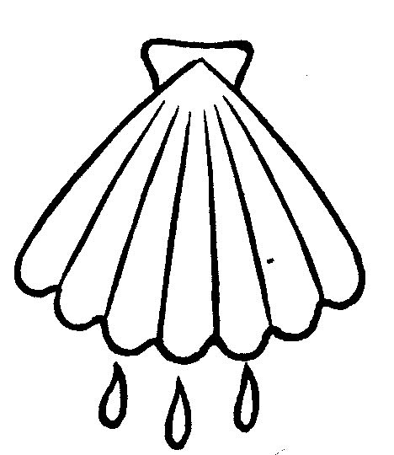 | Shell = Baptism ( A shell was used to pour water)  贝壳= 洗礼(贝壳用来舀水)
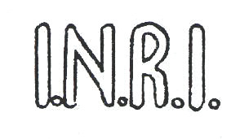 | INRI = Jesus Christ King of the Jews (The first letters of the 4 words in Latin)  INRI = 耶稣基督，犹太人的王（这句话拉丁文的4个首字母）
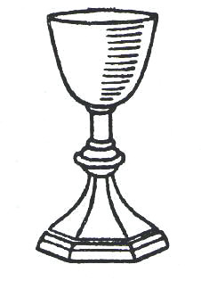 | Cup = Lord’s Supper  杯 = 圣餐
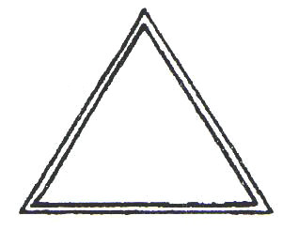 | Triangle (or 3 interlocking circles) = the Trinity(3 sides but 1 triangle)  三角形 (或3个链接的圆环) = 三位一体神(有3条边且是一个三角形)
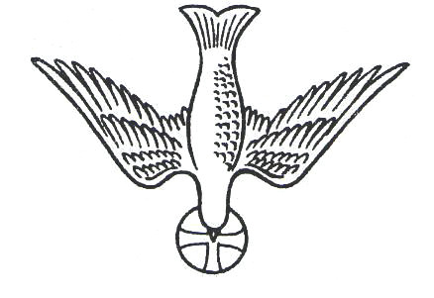 | Dove = Holy Spirit (From story of Jesus’ baptism)  鸽子 = 圣灵(源自耶稣受洗的故事)
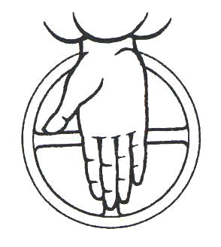 | Hand coming from heaven = God the Father  从上面伸出的手= 天父上帝
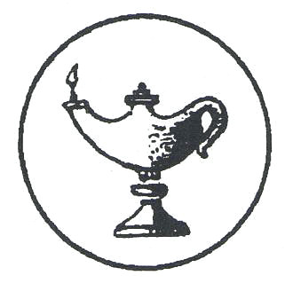 | Lamp = light of God ’s Word  油灯 = 神话语的光
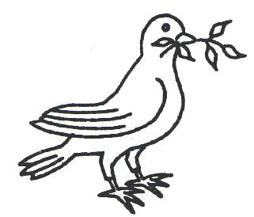 | Dove with olive branch = Peace which comes through faith in Christ  衔着橄榄枝的鸽子 = 由在基督里的信心所带来的平安
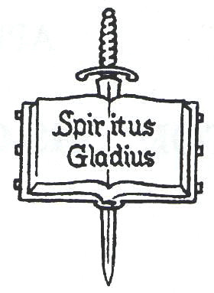 | Sword of the Spirit = preaching of Law and Gospel  圣灵的宝剑= 传讲律法和福音
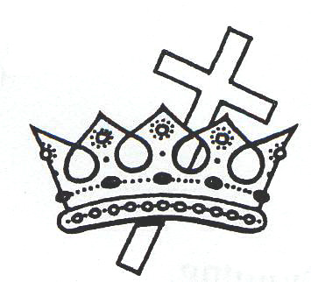 | Crown and Cross = The eternal reward for those faithful through suffering (Revelation 2:10)  冠冕和十字架 = 对在患难中坚信的人的永恒赏赐 (启示录 2:10)
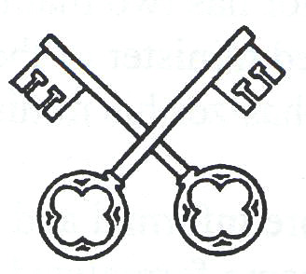 | Keys = Church with its power of the Keys (To lock and unlock heaven)  钥匙 = 教会和她掌管钥匙的权柄（打开关闭天堂）
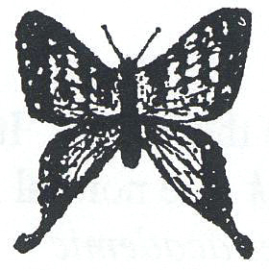 | Butterfly = Resurrection  蝴蝶 = 复活
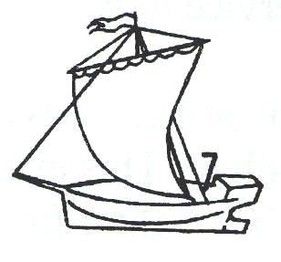 | Ship = the Church  船 = 大公教会
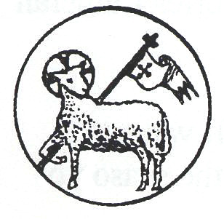 | Lamb of God (Christ) a banner of victory  神的羔羊 (基督)得胜的旗帜
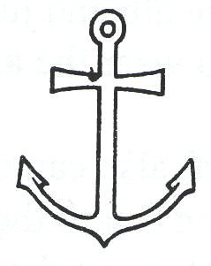 | Anchor = Firm hope of Salvation  锚 = 得救的坚定盼望
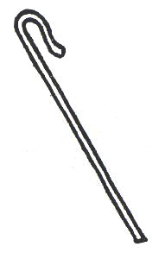 | Shepherd’s rod = Jesus(the Good Shepherd) or Pastors (who shepherd God ’s flock on earth)  牧者的杖= 耶稣（好牧人）或牧师（牧养神在地上的羊）
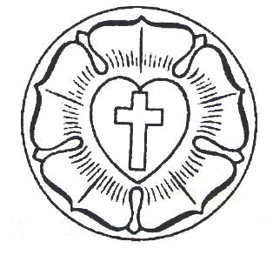 | Luther Rose = Martin Luther and the Lutheran Church  路德玫瑰 = 马丁路德和路德宗教会

